Phase 1
Team: Delta4 | Spring 2026
Unfortunately, we did not finish in time. We struggled to get the Semaphore and Scheduler classes to work together, and couldn’t integrate it into the lab7 codebase.

Screenshots
These are incomplete, but it represents what we have so far.

Unit tests
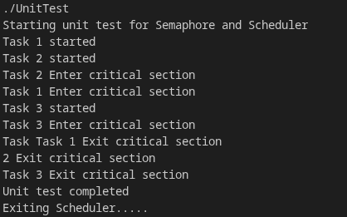

Main program
